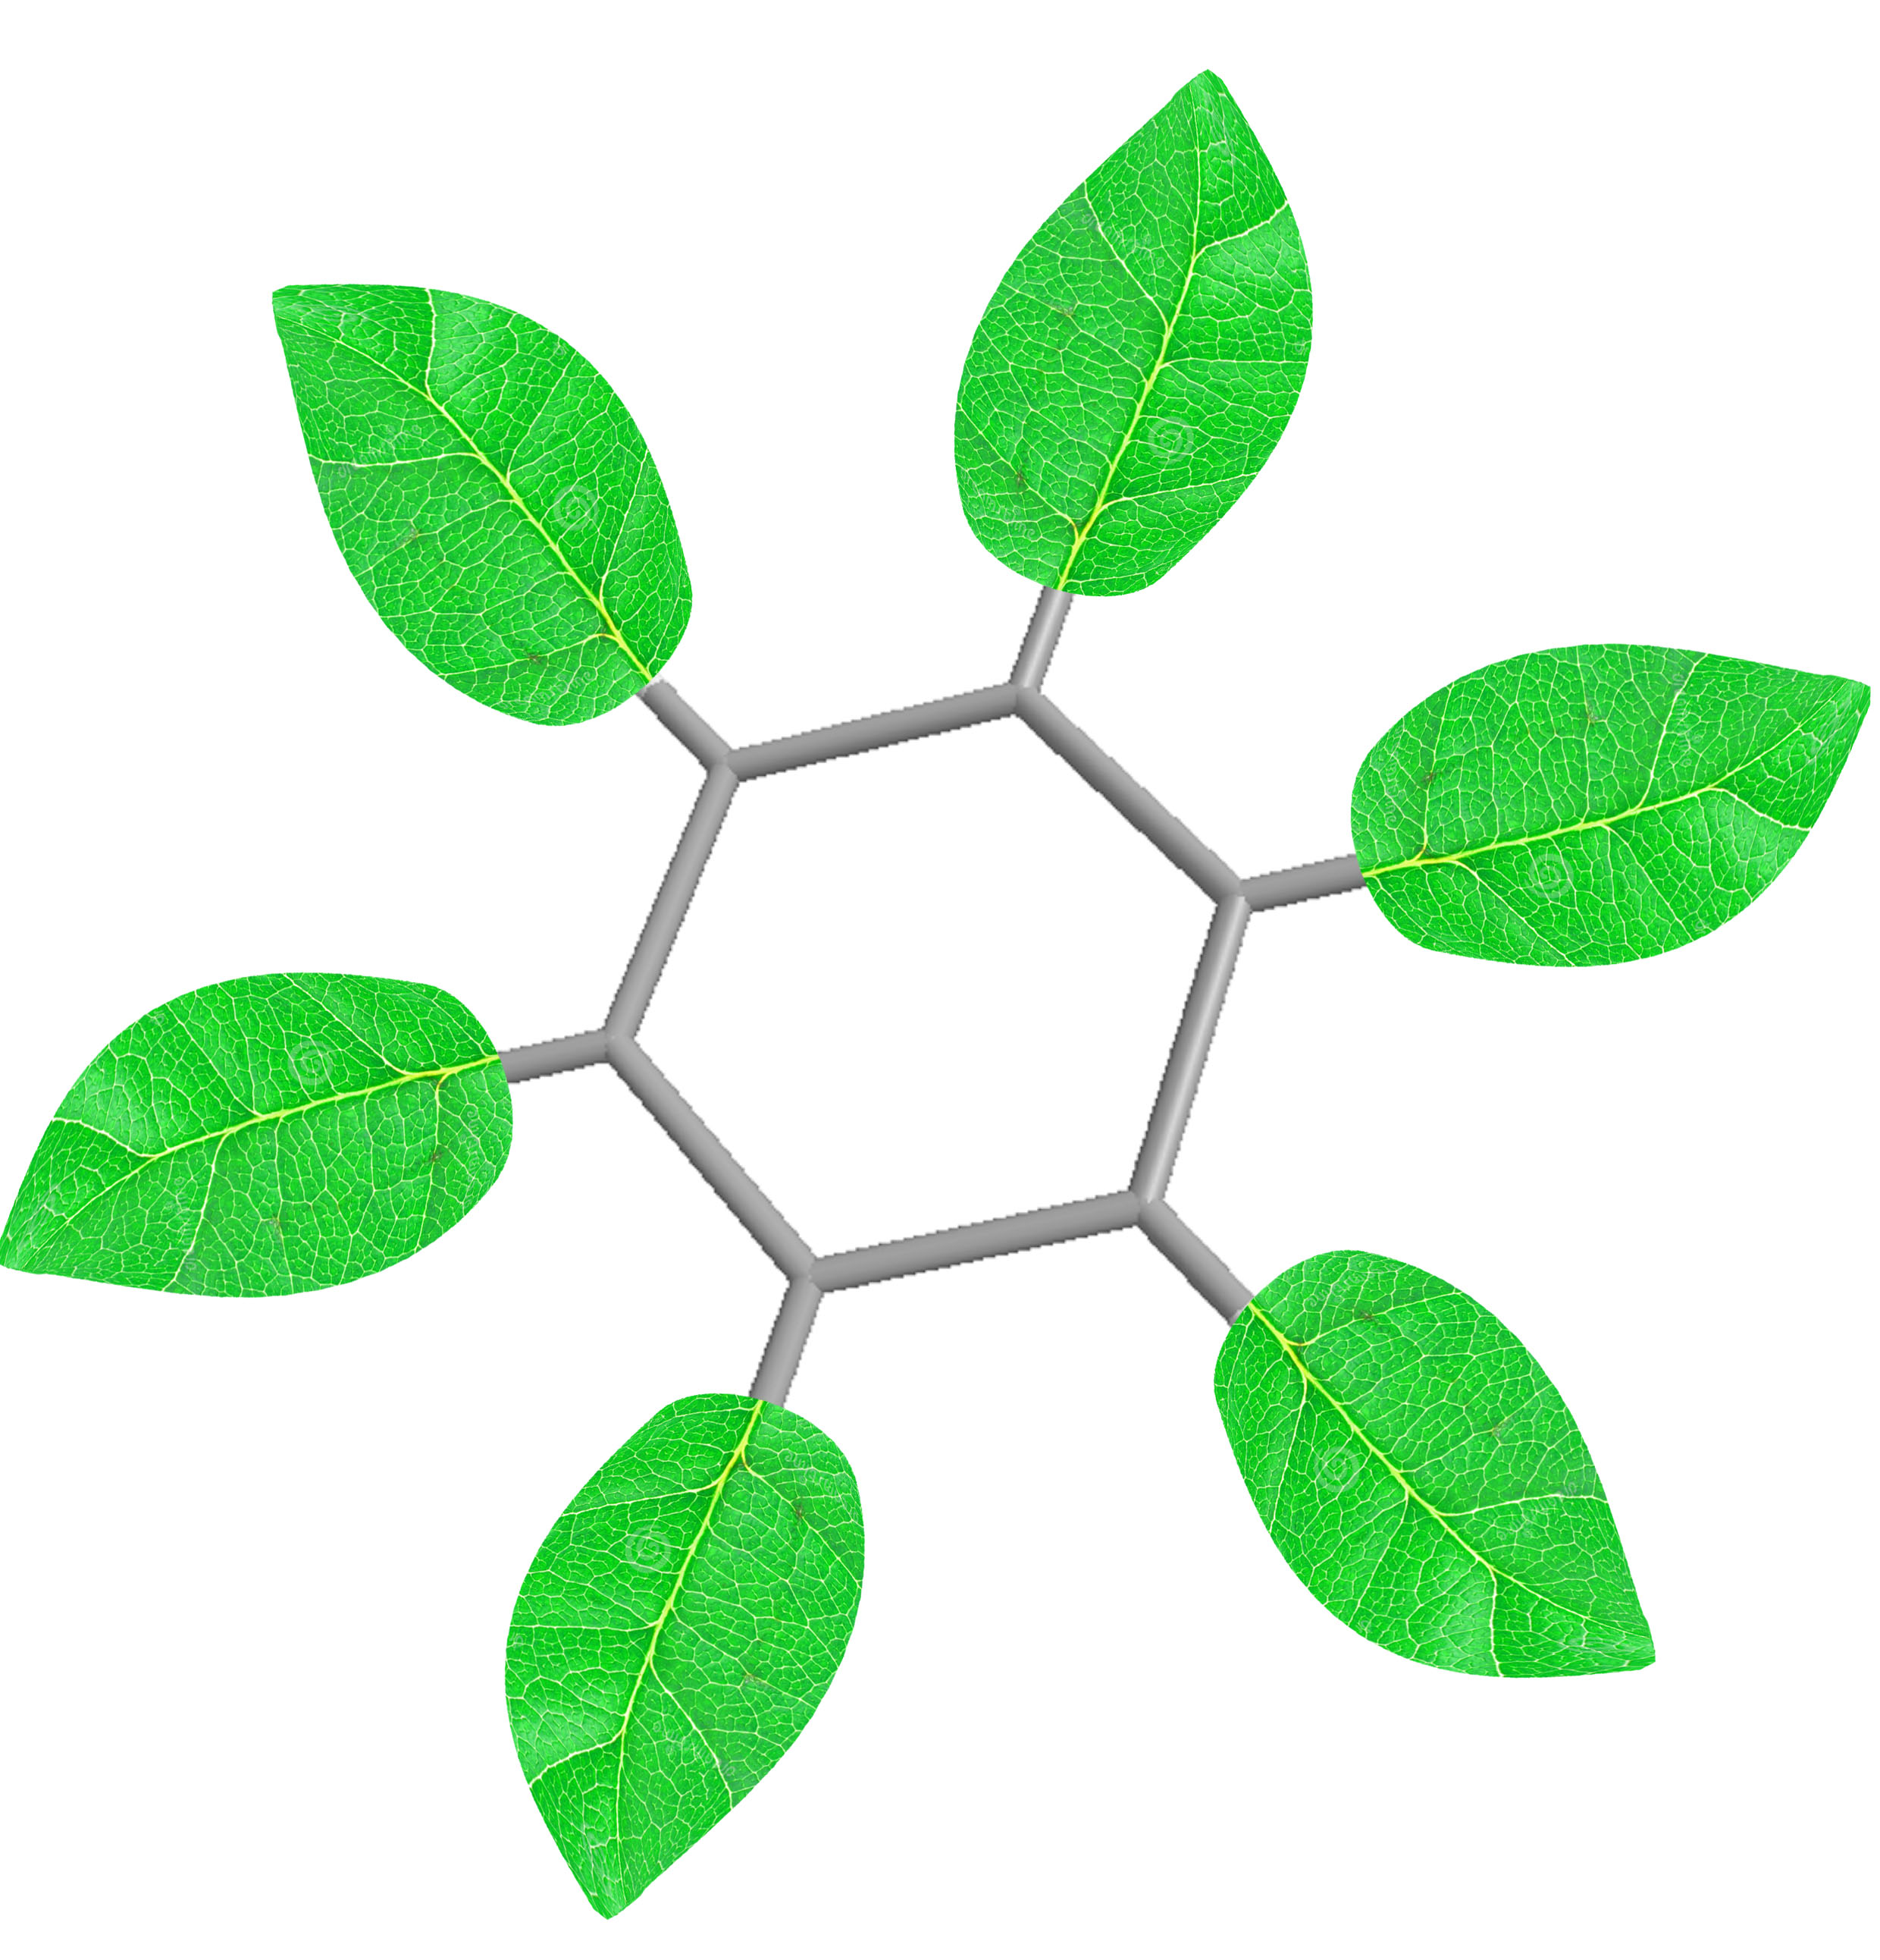
Centre for Doctoral Training in Sustainable Chemistry

Application Form

First Name(s)  Surname/Family name | No
Current most/recent qualification(s) | Institution | Grade/Expected grade | Completion date
Other experience relevant to your application
Area(s) if interest | Synthesis  (Efficient and safer routes to pharmaceuticals, agrochemicals and polymers)  Catalysis  (Metal, organic and enzymatic catalysis, high rates and selectivities)  Energy  (Batteries, fuel cells, organic photovoltaic and thermoelectric materials)  Fundamentals  (Kinetics and mechanisms, spectroscopy and modelling)  Manufacturing  (Additives and 3D printing, life-cycle analysis, cyclic manufacture)  Computational  Fundamentals  Fundamentals  (Data extraction, machine learning, maths in medicine)  Process engineering  (Reactor design, Supercritical fluids, Microwave processing)  Food Science  (Biopolymers, Polysaccharides, genomic analysis)  Biotechnology  (Biovalorisation, Synthetic biology, Platform chemicals)
Please provide further details about your research interests.

Please explain your interest in sustainability, and how your area(s) of interest might contribute towards a sustainable future.

What is your rationale for applying for this particular programme, and why do you think you are a suitable candidate for a place on the course?

